Research question 1
Hypotheses 1:
H0: different ages do not show a bias towards faces from their age group
Ha: different ages show bias towards faces from their age group.
Results
The SPSS output is as follows:
Univariate Analysis of Variance

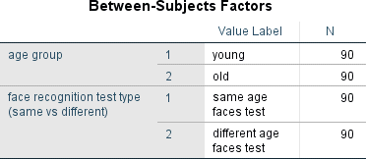
Table 1
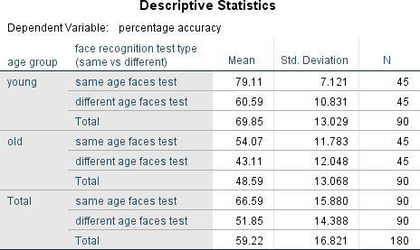
Table 2
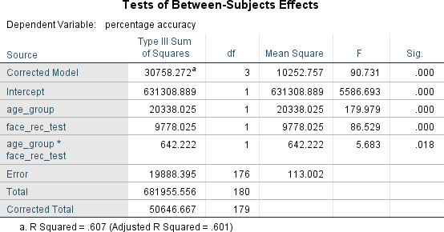table 3
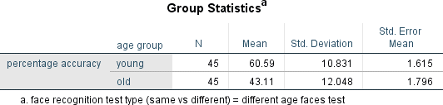
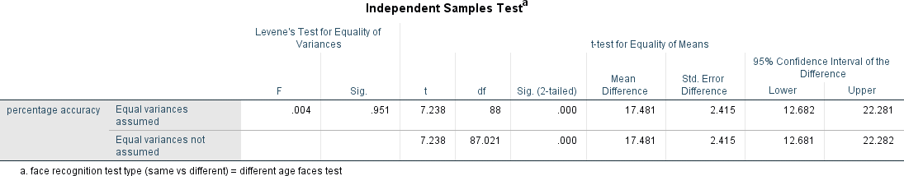table 4 and 4.1
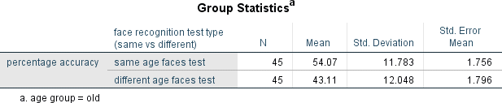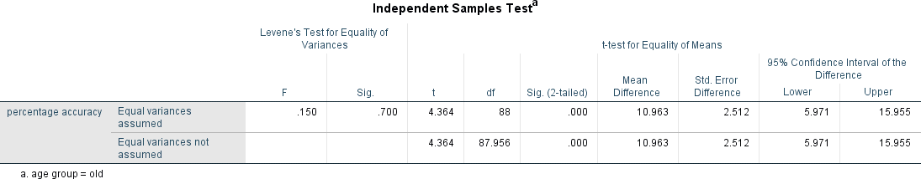 age group = old

Discussion
Cross-age effect means that people are better at facial recognition when they are tested on faces from their age group rather than faces from another age group. In the results section, we want to identify whether age affects facial recognition. For example, do people in the same age group have the same face familiarity or a different one. We need to test hypotheses 1 to see if the evidence supports it.
The univariate analysis of variance in Table 1 includes two types of age groups; the young and the old. The young group is 90 similar to the old which are also 90. Same age recognition face type is also 90 and different age faces test is also 90. This is to avoid outliers and have a perfect conclusion after the data is properly analyzed.
The descriptive statistics in table 2 are important, as they enable the data to be represented in a more meaningful manner in a way that the summary of the young and the old is given. The face recognition type between the young and old is also given in the simpler interpretation of the data in terms of mean and standard deviation and can be well interpreted.
The young different age face test has a larger standard deviation as compared to the young same age face test. This means that different age face tests are spread out over a large number of values as compared to the same age face test. The old different age face test is also high compared to the same age face test. This means that the same age face test age group tend to be very close to the meanwhile the different age face test is spread over a large range of values.
In table 3 on the test between-subject effects, it is clear that the significance levels of age group and face recognition test is less than 0.05. This indicates that we reject the null hypothesis and conclude that the two variables are statistically significant to the percentage accuracy which is the dependent variable. Age group * face recognition test significance level is 0.018 which is less than 0.05 thus we reject the null hypothesis and conclude that there is no difference in cross-age effect, suggesting that different ages do not show bias towards faces from their age group. In conclusion, there is a statistical significance between the young and the old and their percentage accuracy in the face recognition test. This suggests that each age group shows a stronger familiarity with the faces of people in the same age group.
In Tables 4 and 4.1, it is noticed that the significance level is less than 0.05. This suggests that we reject the null hypothesis and conclude that the same age group shows familiarity in faces of the same age group, thus there is no bias in cross-age effect. In the same table of the T-test of different age face tests, the significance level is 0.951 which is greater than 0.05 thus we fail to reject the null hypothesis and conclude that different ages show a bias towards faces from their age group.
Lastly, table 5 and 5.1 shows the T-test for the young and the old. The significance level for the young is 0.001 which is less than 0.05 and we, therefore, reject the null hypothesis and conclude that the young group has a stronger familiarity with faces in both the same and different age groups. The old group's significance level is 0.07 which is greater than 0.05, suggesting that older individuals have difficulty recognizing faces in the same age groups.

Research Question 2
Results
The SPSS results for these research questions are as follows:
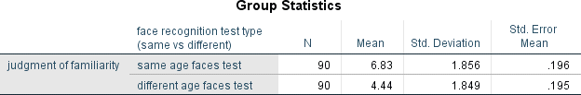
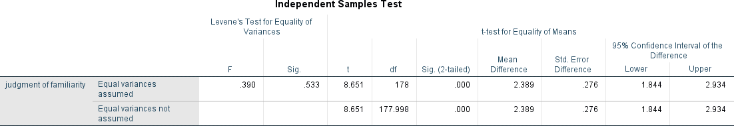table 6 and 6.1
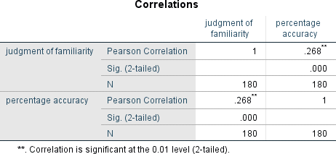
table 7
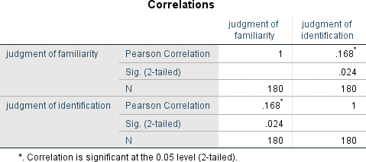
table 8

Hypothesis 2:
H0: familiarity does not mediate the effect of the age similarity of the face recognition test on face recognition test performance.
Ha: familiarity mediates the effect of the age similarity of the face recognition test on face recognition test performance
Discussion
Table 6 and 6.1 shows the T-test for the research question. The standard deviation for the judgments of familiarity of the same age face test is greater than the standard deviation for different age faces test. This means that the same age face test is spread out over a large number of values compared to different age face test. The T value is 8.651 which is greater than 1.96, and the significance level is 0.533 which is greater than 0.05. Therefore, it can be concluded that there is no support for the theory that familiarity mediates the effect of the age similarity of the face recognition test on the face recognition test performance. Also, age similarity on the face recognition test does not affect judgments of the familiarity of faces; therefore, familiarity judgment does not affect face recognition test performance. The Pearson correlation in Tables 7 is 0, this therefore suggests no existence of a linear relationship between judgment of familiarity and percentage accuracy. The correlation in table 8 is 0.024 which is close to 0 thus suggests no existence of a linear relationship between judgment of familiarity and judgment of identification. The conclusion therefore is familiarity does not mediate the effect of the age similarity of the face recognition test on face recognition test performance.
Research Question 3:
Hypothesis
H0: social identity does not mediate the effect of the age similarity of the face recognition test on face recognition test performance.
Ha: social identity mediates the effect of the age similarity of the face recognition test on face recognition test performance
Results
The results output are as shown below:
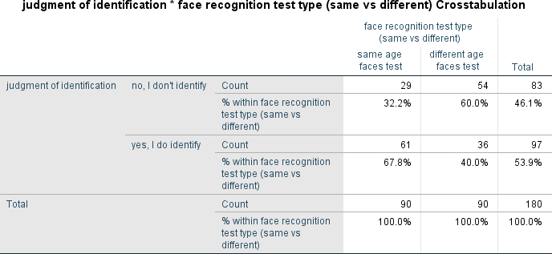
Table 9
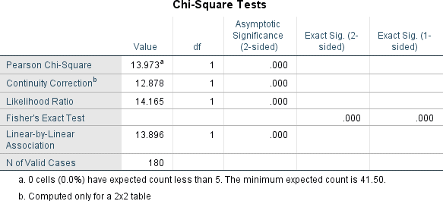
Table 10

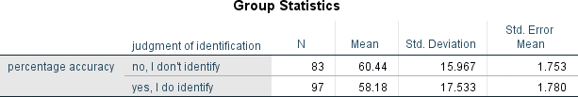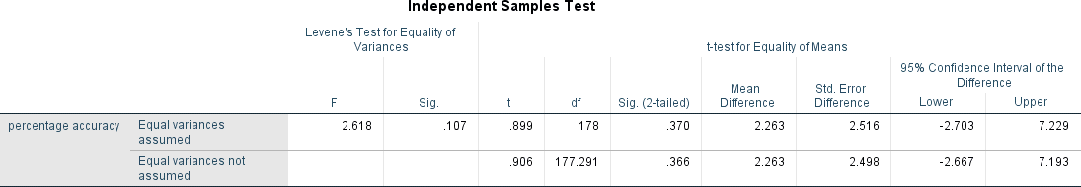table 11 and 11.1

Discussion
It is noted from table 9 that judgment identification for the same age faces a test that does not identify face recognition makes up 32.2% of the sample (29/180). For the different age face tests that do not identify, the face recognition face test makes up 60% of the sample (54/180). The same age faces a test that does identify the face recognition faces type makes up 67.8% of the sample (61/180). The different ages face tests that did identify the face recognition test type accounts for 40% of the sample (36/180). From the above cross-tabulation, we reject the null hypothesis and conclude that the age similarity of the face recognition test affects the judgments of identification, suggesting that identification judgments also affect face recognition test performance.
In table 10 on Chi-Square tests, the value of the test statistic is 13.973, suggesting that the footnote for this statistic pertains to our theory. No cells had an expected count of less than 5 therefore our alternative hypothesis is correct. Therefore, social identity mediates the effect of the age similarity of the face recognition test on face recognition test performance
Table 11 and 11.1 shows the group statistics of judgments identification and the percentage accuracy. It is noted that the standard deviation for those who identify (yes) is larger than the ones who don’t identify the face recognition test. This also supports our alternative hypothesis and thus the theory we are investigating. The significance level is 0.37 which is less than one. Therefore, we fail to reject the null hypothesis and conclude that social identity mediates the effect of the age similarity of the face recognition test on face recognition test performance.
References
Andersen EB (1997), Introduction to the Statistical Analysis of Categorical Data. Springer-Verlag.
Anderson TW, Finn JD (1996), The New Statistical Analysis of Data. Springer-Verlag NewYork, Inc.
Barlow RE, Proschan F (1975), Statistical Theory of Reliability and Life Testing. Holt, Rinehart & Winston, Inc.

